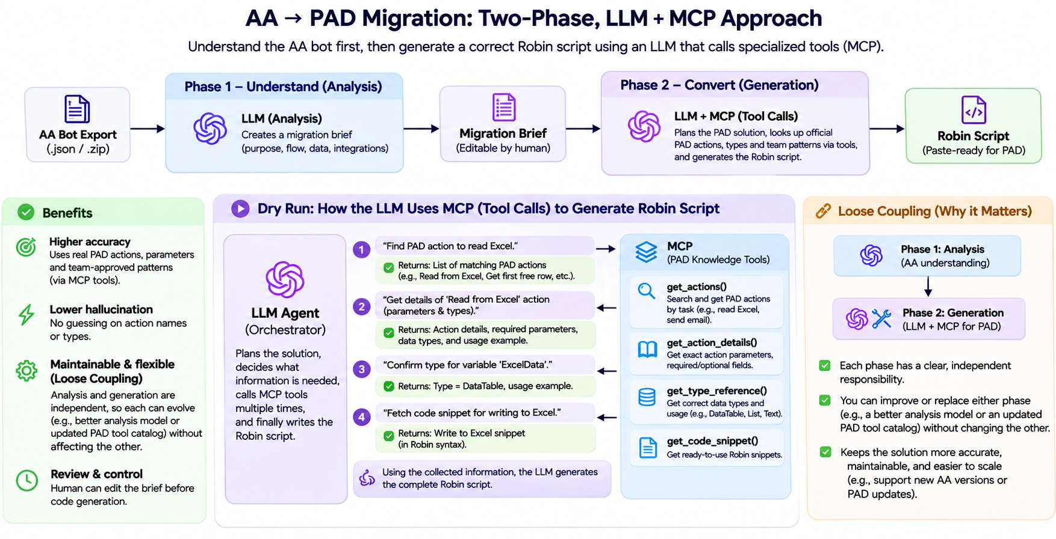

End-to-end workflow (how a migration run works)

Step | What happens | Who / what is involved
Upload | User provides one or more AA bot exports. | Web UI
Inspect (optional preview) | We extract structure from the JSON: commands, packages, variables, approximate size—without calling an LLM. | Deterministic code
Analyze | An LLM writes a migration brief in Markdown: purpose, flow, data, integrations, uncertainties. | LLM only (no MCP)
Review | The user edits the brief so business logic and priorities are right before code is generated. | Human in the loop
Generate | An agent (LLM) plans the PAD solution and looks up actions, types, and team patterns via pad-mcp, then outputs pasteable Robin. | LLM + MCP
Use | The developer copies Robin into PAD, converts to actions, tests, and refines. | PAD + developer
Tested Outputs:

